This document is written by Xinyang Yu, which summarises the preprocessing and QC procedures of methylation data were conducted by Xinyang Yu (for IMAGEN and ESTRA cohorts) and Di Chen (for STRATIFY cohort) after internal discussion at King’s College London. For any questions or further details, please contact Xinyang (xinyang.1.yu@kcl.ac.uk), Di (di.1.chen@kcl.ac.uk), and Sylvane (sylvane.desrivieres@kcl.ac.uk).

The outlined procedure details the preprocessing and QC steps applied to methylation data from the IMAGEN FU2, IMAGEN FU3, STRATIFY, and ESTRA cohorts. Each cohort underwent identical and separate preprocessing and QC procedures. Figures relevant to the QC procedures of each in cohort are provided below.

**Preprocessing and quality assessments of methylation data**

DNA methylation data from all cohorts (i.e., IMAGEN FU2, IMAGEN FU3, STRATIFY and ESTRA) were analysed using the Infinium MethylationEPIC v2.0 BeadChip Kit, that targets over 935,000 CpG sites in the most biologically significant regions of human methylome, while maximising backwards compatibility in MethylationEPIC v1.0 (<https://emea.illumina.com/products/by-type/microarray-kits/infinium-methylation-epic.html>). In the EPIC v2.0, 77.63% are homologous with the first version, and more than 200,000 of which are new CpGs covering regions located in the open chromatin and enhancer regions identified by the ENCODE and FANTOM5 projects.

For validation of this new EPIC DNA methylation array: <https://www.ncbi.nlm.nih.gov/pmc/articles/PMC9988339/>

All scripts used for preprocessing and QC for the methylation data can be found at: <https://github.com/XinyangYu918/DNA-methylation-preprocessing>.

After the removal of samples of broken EDTA tubes when thawing or those with poor DNA concentration, below is the total number of raw methylation data we received from the L&B lab in December 2023.

|  |  |  |  |  |
| --- | --- | --- | --- | --- |
| Cohort | IMAGEN FU2 | IMAGEN FU3 | STRATIFY | ESTRA |
| N of available sample before QC | 1332 | 943 | 614 | 160 |

For preprocessing and QC, we initially used the “preprocessRaw”, “mapToGenome”, “ratioConvert”, and “getBeta” functions from the “minfi” R package to load the raw data, convert the Red/Green channel data from an Illumina methylation array into methylation signals, without applying any normalisation. The raw methylation signals were then computed into beta values, calculated as (methylated signal)/(methylated + unmethylated signals) at each CpG site.

For population-based cohorts (i.e., IMAGEN FU2 and IMAGEN FU3), within- and between- sample normlisation was performed using the stratifies quantile normalisation (using “preprocessQuantile” function). Note that the algorithm used for such a normalisation method relies on the assumptions necessary for quantile normalisation to be applicable and thus is not recommended for cases where global changes are expected, such as in cancer versus control comparisons. For clinical samples (i.e., STRATIFY and ESTRA), we performed both quantile normalisation and functional normalisation (using “preprocessFunnorm” function), which removes unwanted variation by regressing out variability explained by the control probes present on the array.

**QC procedures**

All quality assessments were preformed using the “minfi” package in R, with specific functions described below. To assess sample quality and detect batch effects, we first applied MDS to check bad samples and batch effect. Furthermore, Principal Component Analysis (PCA) was conducted to examine batch effects and to determine the percentage of variance explained by each principal component.

**Use MDS to check bad samples**

Here, we consider slide and sex (not for the ESTRA cohort) as potential confounding variables and to examine how they impact on the first component of the methylation data. In general, all samples showed good signals.

**For slide (the barcodes of plates) effect on the first PC of the methylation signals**

IMAGEN FU2:



IMAGEN FU3:



STRATIFY:



ESTRA:



**For sex effect on the first PC of the methylation signals**

IMAGEN FU2:



IMAGEN FU3:



STRATIFY:



**PCA distribution of methylation signals**

The following figures show the PCA distribution (i.e., screen plots indicating the variances explained by components extracted) of methylation signals for all probes on autosomes. The first 4 PCs will be selected for further analyses as control variables.

IMAGEN FU2: IMAGEN FU3:

STRATIFY: ESTRA:



Individuals who were out of a normal range (i.e., median + 3 standard deviation, or median -3 standard deviation) based on the first four PCA components were marked as outliers and removed from downstream analyse.

* IMAGEN FU2: N = 37 participants were removed
* IMAGEN FU3: N = 31 participants were removed
* STRATIFY: N = 14 participants were removed
* ESTRA: N = 13 participants were removed

**Predicting sex using methylation data**

Sex information was estimated using “getSex” function. Then we examine it there is any mismatch between self-reported and predicted sex. Participants with mis-match sex information were marked as outliers and removed from downstream analyses.



IMAGEN FU2: 19 participants were removed due to discrepancy between their self-reported and predicted sex.



IMAGEN FU3: 9 participants were removed due to discrepancy between their self-reported and predicted sex.



STRATIFY: 6 participants were removed due to discrepancy between their self-reported and predicted sex.

ESTRA: All participants were female and their predicted were females. No one was excluded at this step.

**Batch effects**

Then we plotted the potential batch effects on the first four PCs of the methylation data. We consider sex (except for the ESTRA cohort), slide numbers (barcodes of the plates), location on the arrays, and recruitment sites as potential confounders.

**For effects of slides (barcodes of the plates) on the first four methylation PCs,**

IMAGEN FU2:

No significant effects of slides on the PCs of methylation data.

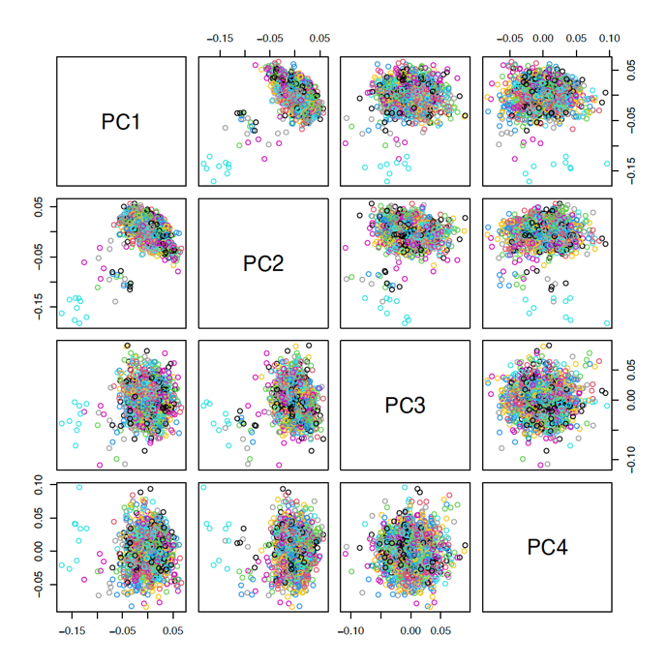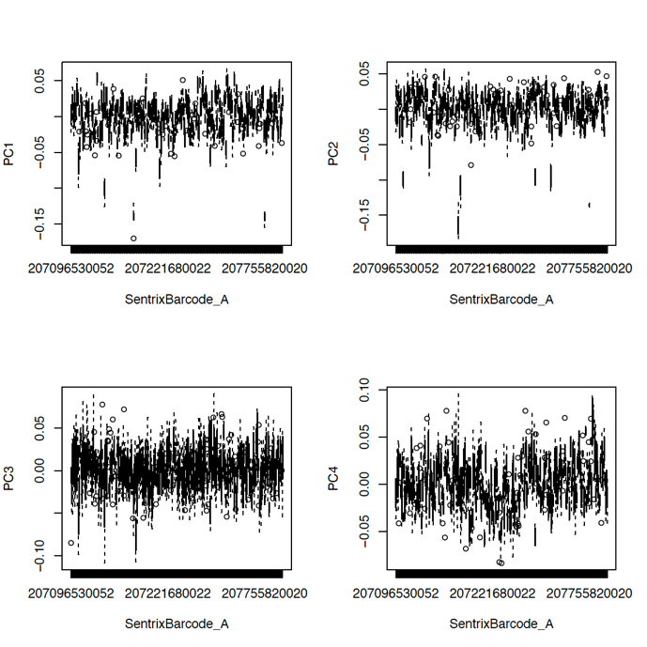

IMAGEN FU3:

No significant effects of slides on the PCs of methylation data.

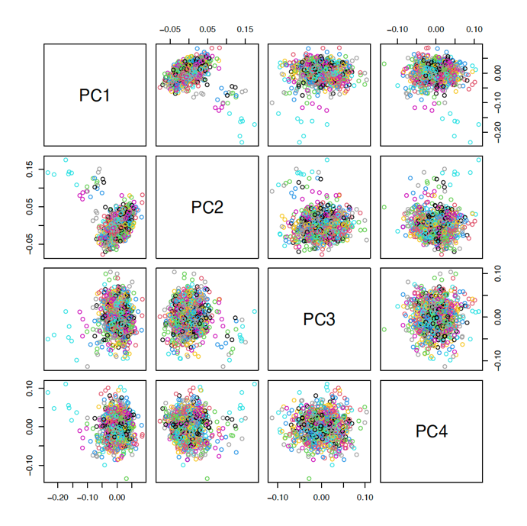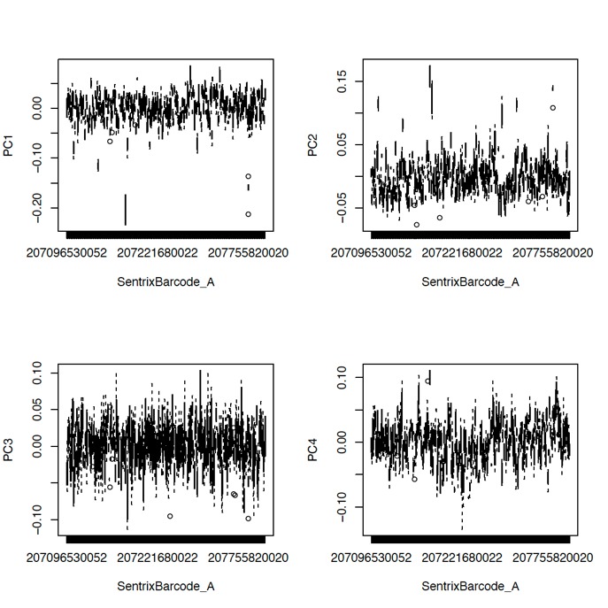

STRATIFY:

No significant effects of slides on the PCs of methylation data.

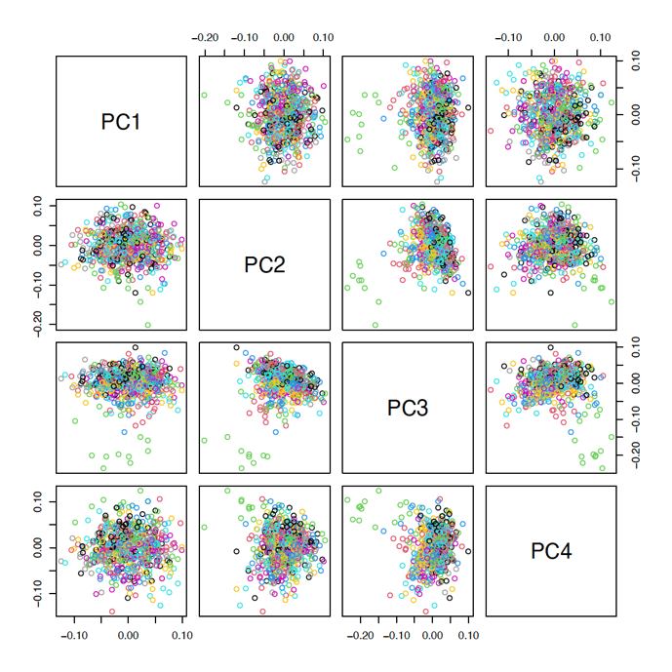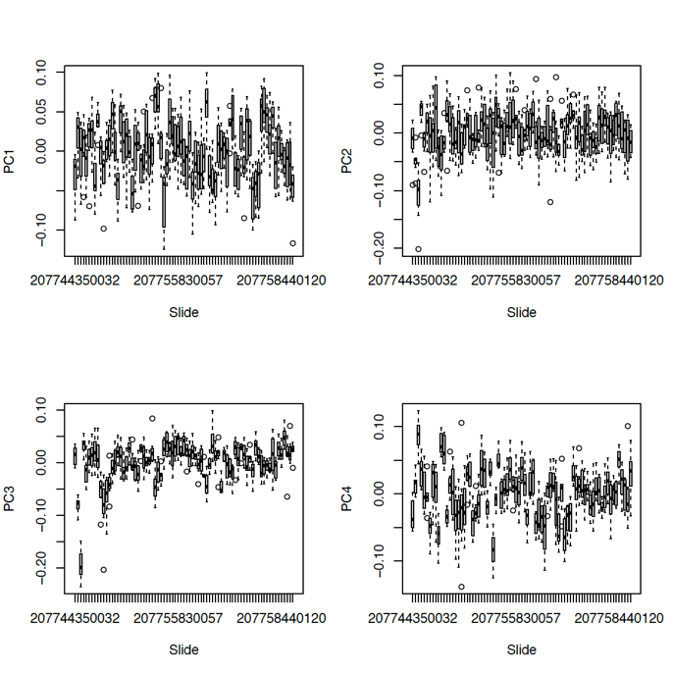

ESTRA:

There are weak effects of slides on the third PCs of methylation data.

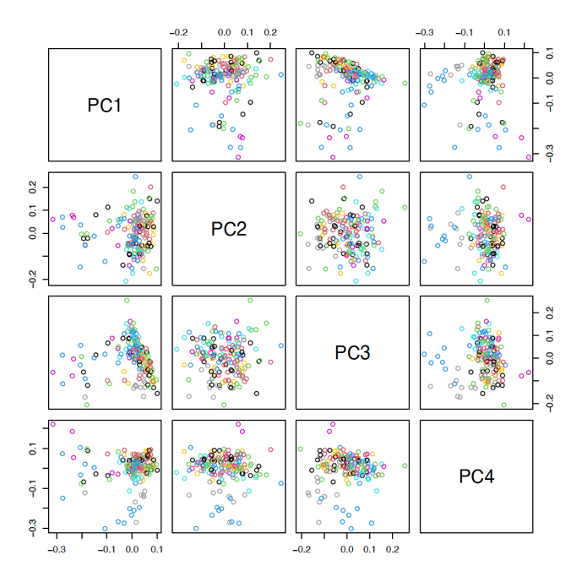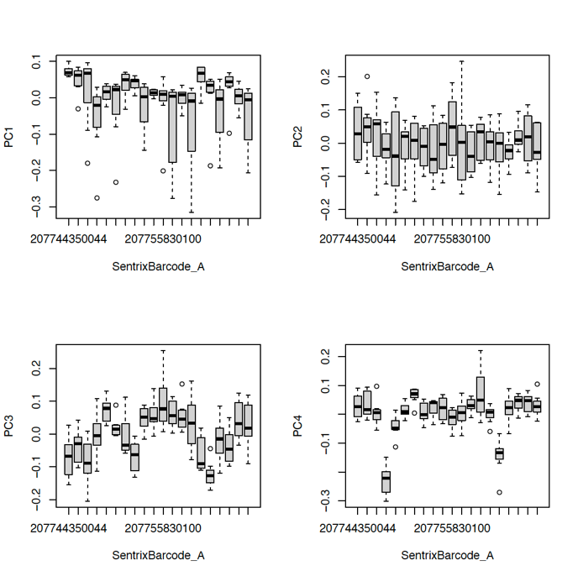

**For effects of location (i.e., locations on the arrays) on the first four methylation PCs,**

IMAGEN FU2:

No significant effects of location on the arrays on the PCs of methylation data.

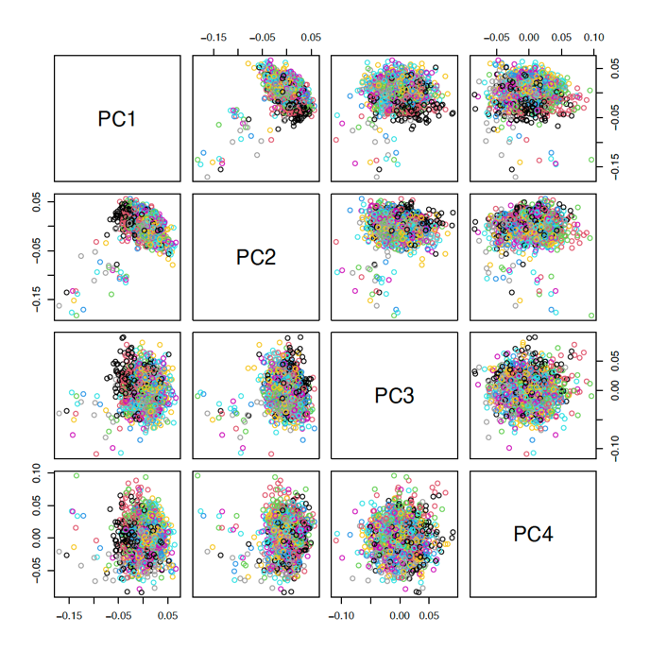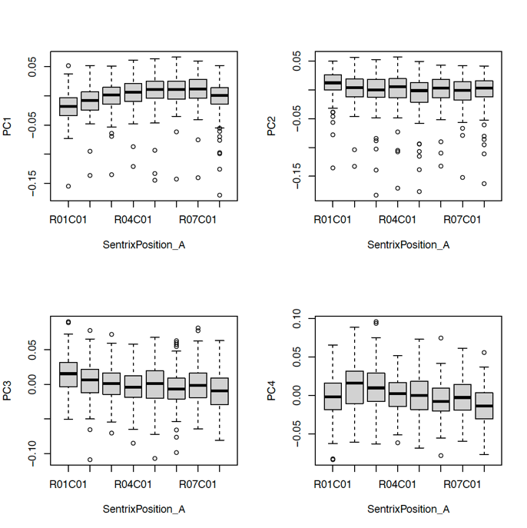

IMAGNE FU3:

No significant effects of location on the arrays on the PCs of methylation data.

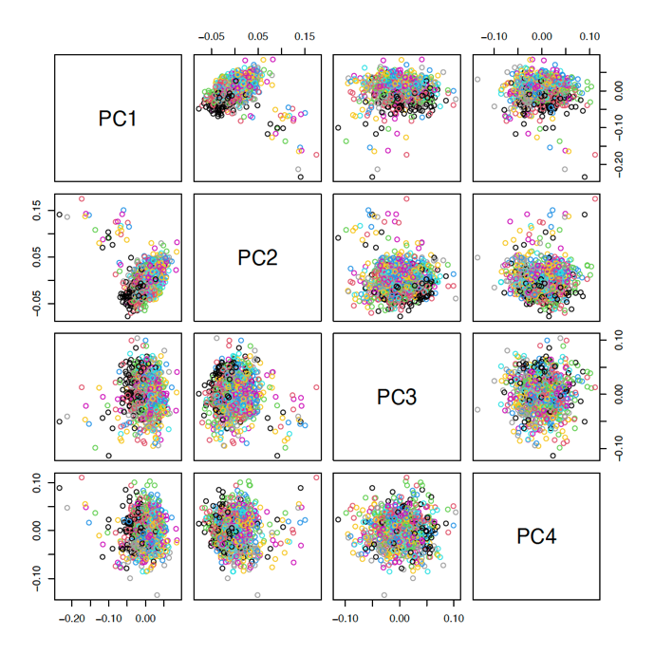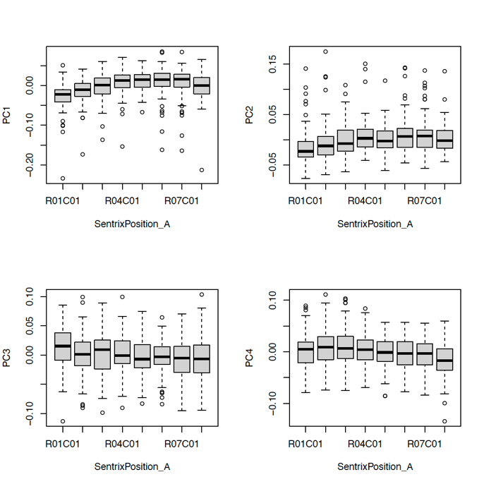

STRATIFY:

There are weak batch effects of location on the arrays on the first PCs of methylation data.

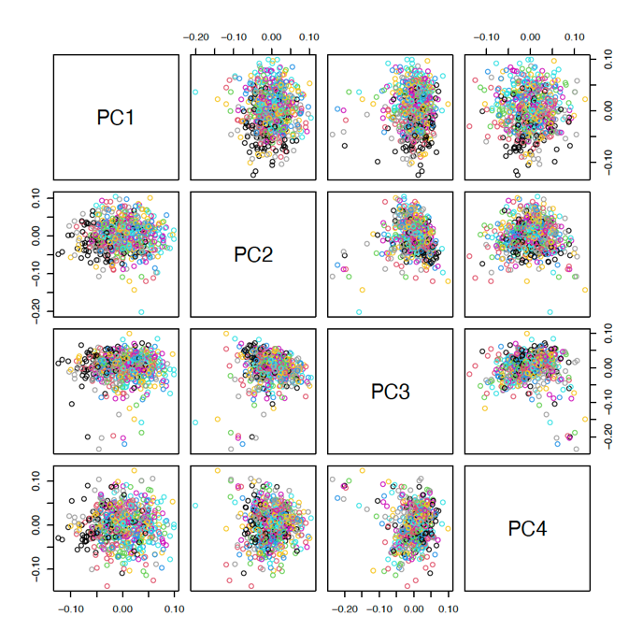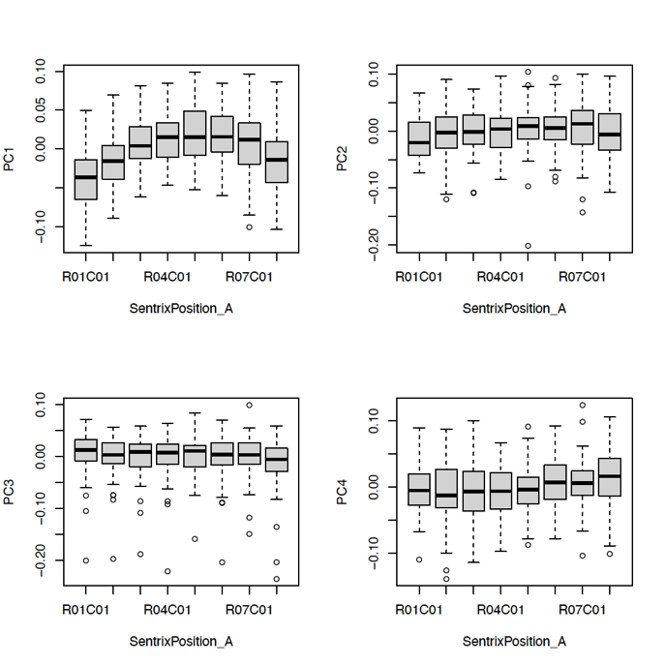

ESTRA:

There are some batch effects of location on the arrays on the third PCs of methylation data.

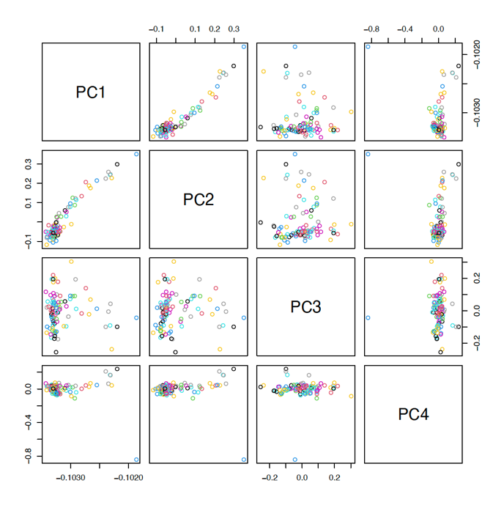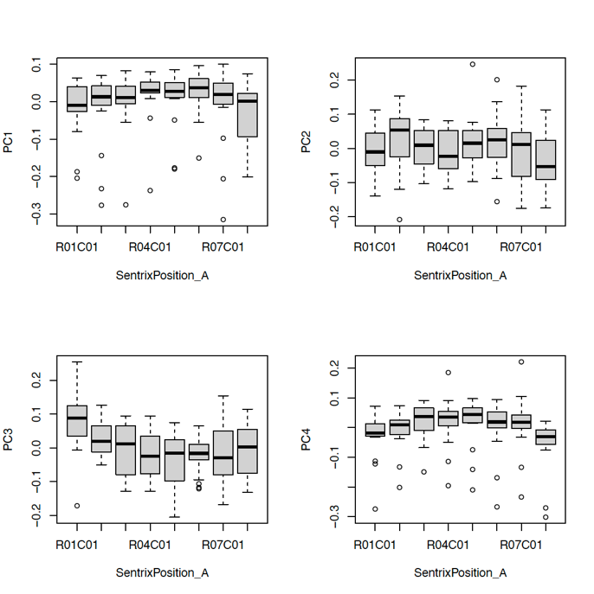

**For effects of sex on the first four methylation PCs,**

IMAGEN FU2:

No significant effects of sex on PCs of the methylation levels were found.

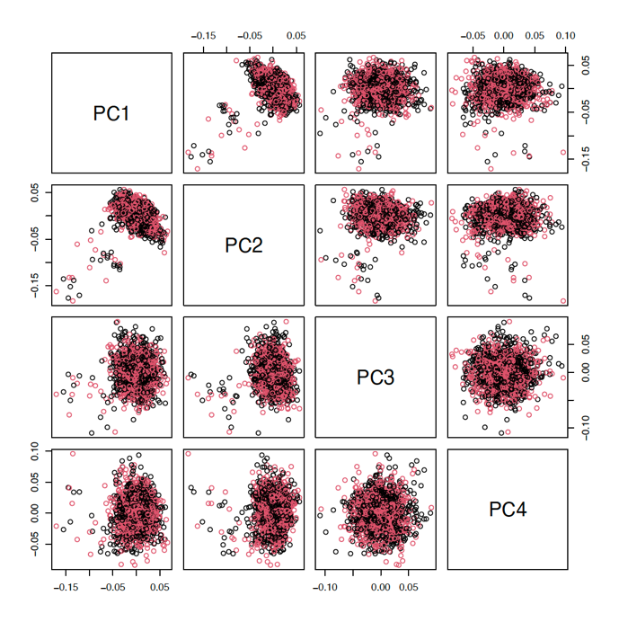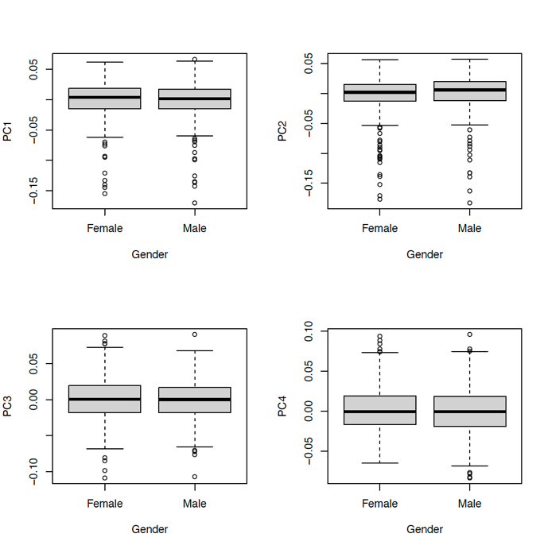

IMAGEN FU3:

No significant effects of sex on PCs of the methylation levels were found.

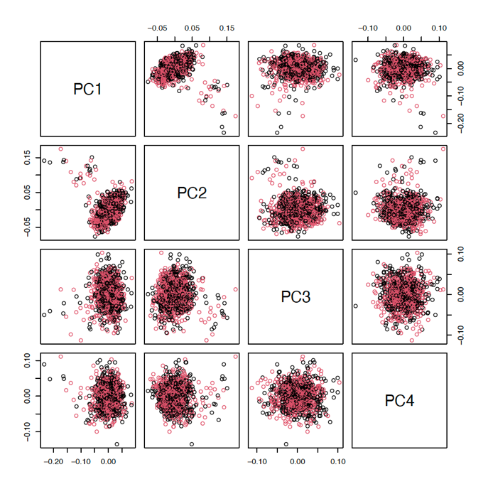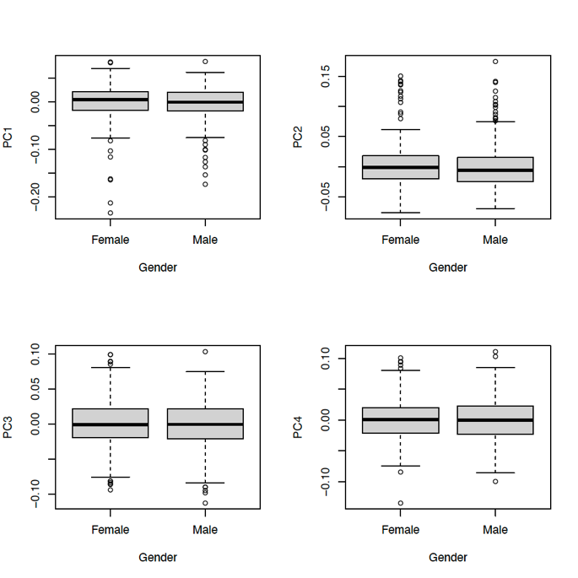

STRATIFY:

No significant effects of sex on PCs of the methylation levels were found.

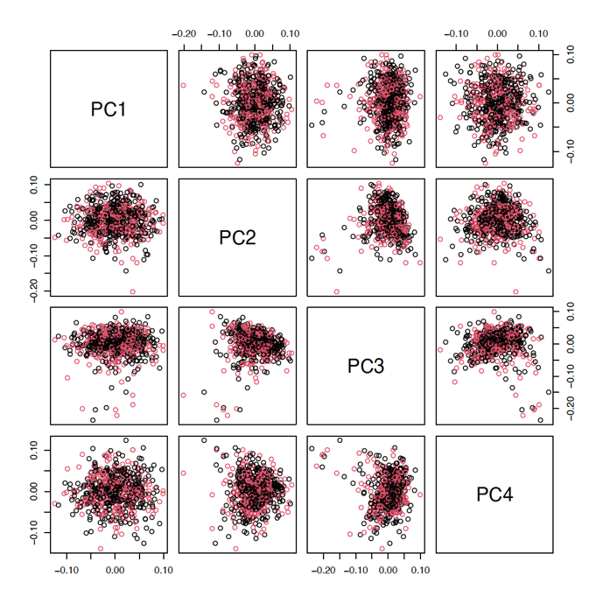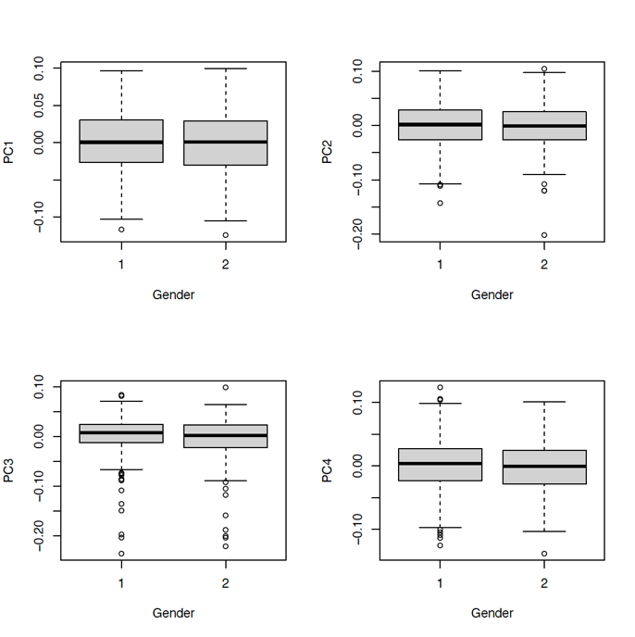

**For effects of recruitment sites on the first four methylation PCs,**

IMAGEN FU2:

No significant effects of recruitment sites on PCs of the methylation levels were found.

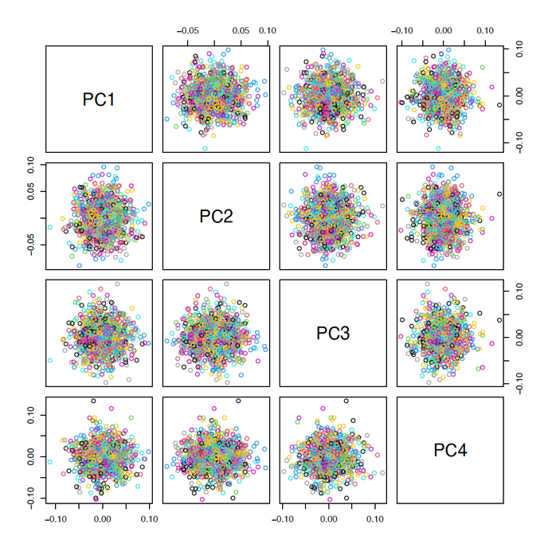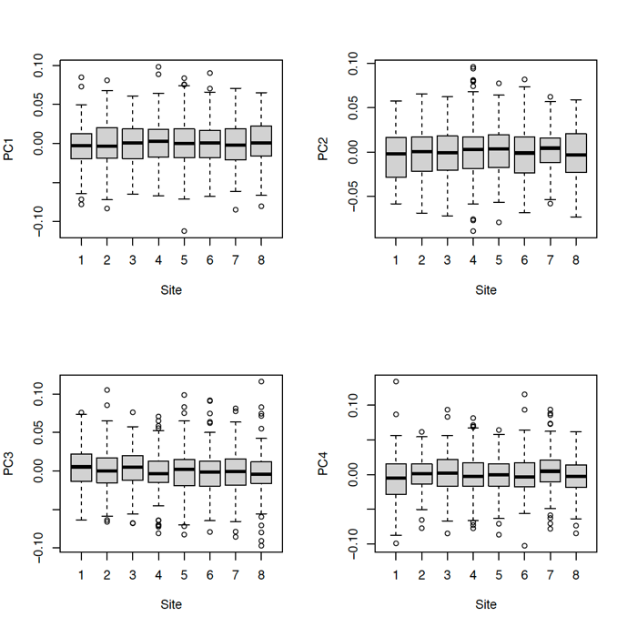

IMAGEN FU3:

No significant effects of recruitment sites on PCs of the methylation levels were found.

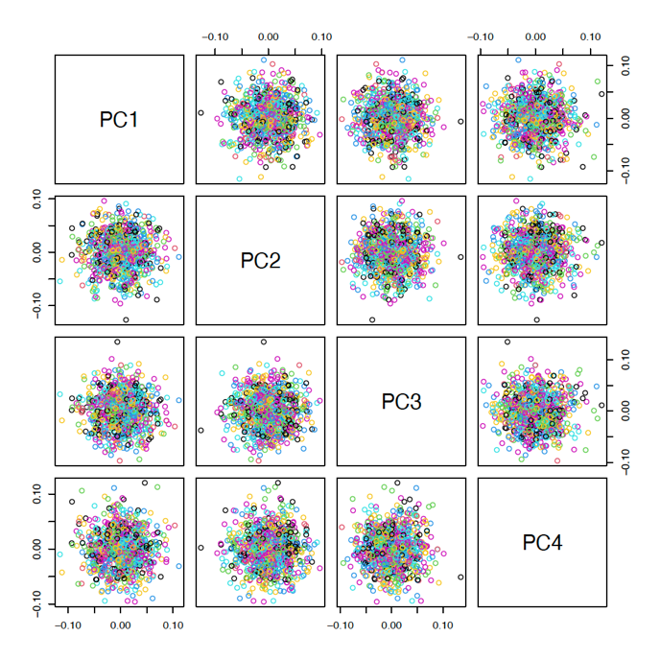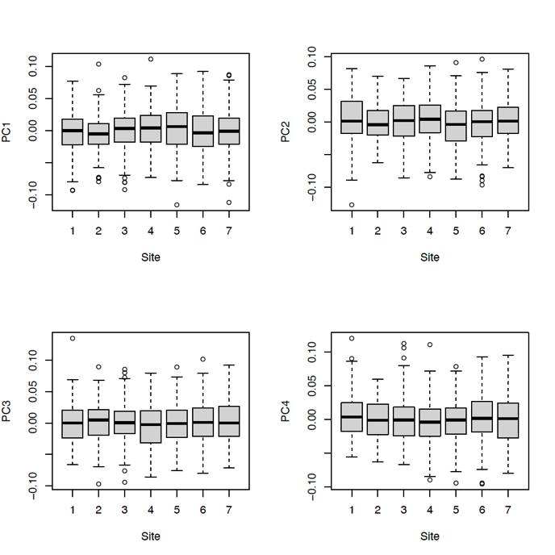

STRATIFY:

No significant effects of recruitment sites on PCs of the methylation levels were found.

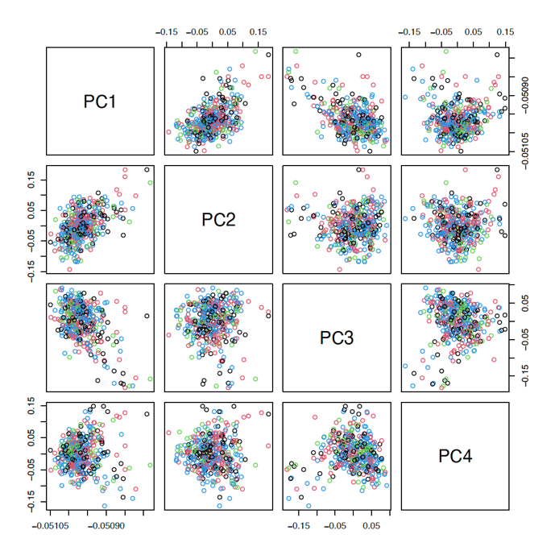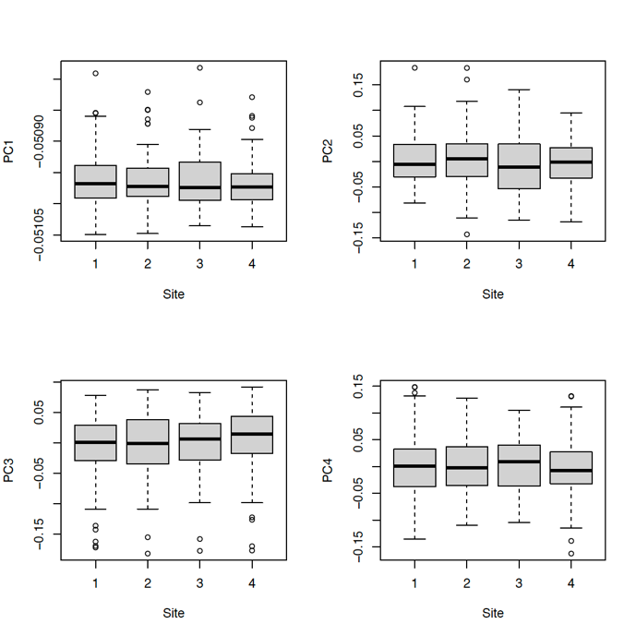

ESTRA:

No significant effects of recruitment sites on PCs of the methylation levels were found.

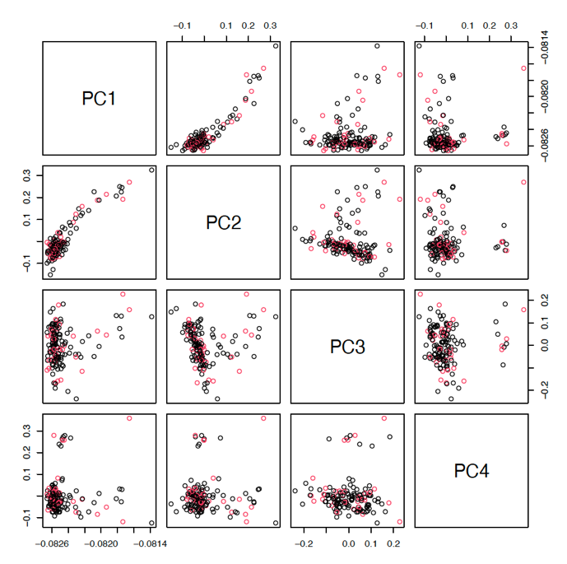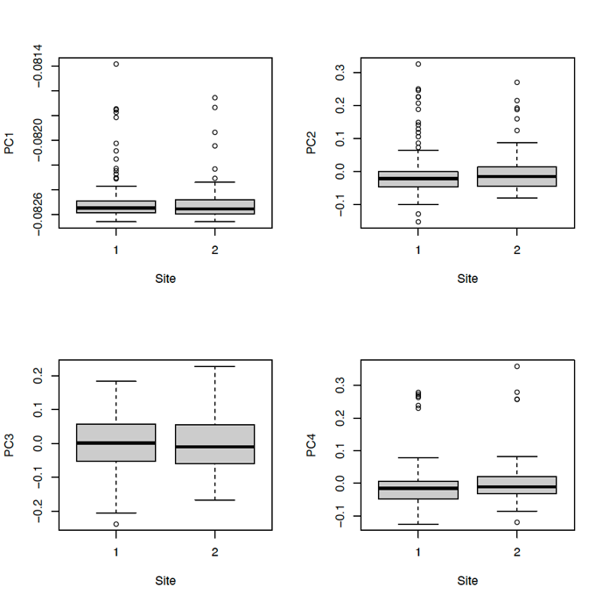

**Estimated cell proportion**

The “FlowSorted.Blood.EPIC“ R package was used to estimate the cell counts, which uses Neutrophils instead of Granulocytes. When using the newer EPIC microarray minfi estimates of cell type composition using the FlowSorted.Blood.450k package are less precise compared to actual cell counts (doi:10.1186/s13059-018-1448-7.)

IMAGEN FU2 IMAGEN FU3



STRATIFY ESTRA



**PCA distribution of cell proportion**

IMAGEN FU2 IMAGEN FU3



STRATIFY ESTRA



The first two PCs were derived for downstream analyses as covariates.

**Other information important for downstream analyses**

**IMAGEN FU2:**

The raw data contains of 1332 participants. During the QC:

* 37 participants were removed because of their beta values were out of normal range (mean ± 3SD)
* 19 participants were removed due to a mismatch between their self-reported and predicted sex
* 5 samples were removed due to correspond to duplicate participants.

The final sample size for IMAGEN FU2 is 1271.

PSC2 codes for the 37 participants who were removed due to their outlier methylation signals:

|  |  |  |  |  |  |  |
| --- | --- | --- | --- | --- | --- | --- |
| 469693 | 1938036 | 3287674 | 5352545 | 12578656 | 14438794 | 14786947 |
| 15705369 | 18952353 | 19094771 | 21777172 | 22202071 | 24495953 | 26461756 |
| 32581973 | 37236832 | 38361038 | 38472262 | 40233957 | 43057617 | 53938707 |
| 60334165 | 61507009 | 67110223 | 68173365 | 69832522 | 69903630 | 70086597 |
| 74104786 | 74226093 | 76936765 | 80383784 | 84158838 | 84167593 | 85348240 |
| 88315066 | 88505139 |  |  |  |  |  |

PSC2 codes for the 19 participants removed due to mismatched self-reported and predicted sex:

|  |  |  |  |  |  |  |
| --- | --- | --- | --- | --- | --- | --- |
| 3023509 | 4254555 | 4941007 | 7843654 | 13243745 | 14141334 | 18490401 |
| 27255432 | 55757334 | 56117209 | 58294120 | 59591525 | 63961493 | 66619767 |
| 72165508 | 80739123 | 83589851 | 87109149 | 92671066 |  |  |

PSC1 codes for the duplicated samples (these samples have been removed from the downstream analysis):

|  |  |  |  |  |
| --- | --- | --- | --- | --- |
| 80000881613 | 50000220217 | 60000339732 | 80000383725 | 80000887414 |

**IMAGEN FU3:**

The raw data contains of 943 participants. During the QC:

* 31 participants were removed because of outliers
* 9 participants were removed due to sex mismatch

The final sample size for IMAGEN FU3 is 903.

PSC2 codes for the 31 participants who were removed due to their outlier methylation signals:

|  |  |  |  |  |  |  |
| --- | --- | --- | --- | --- | --- | --- |
| 469693 | 1689886 | 1938036 | 3287674 | 5352545 | 9156142 | 9682526 |
| 11920822 | 12578656 | 13097762 | 13377477 | 14438794 | 14759699 | 16275727 |
| 24495953 | 26461756 | 32581973 | 38472262 | 56896962 | 66929613 | 68173365 |
| 71766352 | 73312240 | 74104786 | 74226093 | 83507055 | 83550867 | 84158838 |
| 92318687 | 92432902 | 94768500 |  |  |  |  |

PSC2 codes for the 9 participants removed due to mismatched self-reported and predicted sex:

|  |  |  |  |  |  |  |
| --- | --- | --- | --- | --- | --- | --- |
| 39838208 | 48550187 | 64564726 | 59791765 | 15059321 | 20843854 | 22888407 |
| 75809342 | 75814401 |  |  |  |  |  |

**ESTRA:**

The raw data contains of 160 participants. During the QC:

* 12 participants were removed due to outliers
* 1 participant was removed due to outliers in quantile normalisation

PSC2 codes for the 12 participants who were removed due to their outlier methylation signals:

|  |  |  |  |  |  |
| --- | --- | --- | --- | --- | --- |
| 21038930 | 115233441 | 125097216 | 133425854 | 134251460 | 160524572 |
| 167168222 | 171399566 | 174848204 | 183567670 | 197987787 | 198486817 |

One sample was removed due to outliers in the quantile normalisation

10001850895

There will be two versions of QCed data available, and the appropriate version should be selected based on study design.

* Version 1: including IMAGEN participants (total N = 147), use this version when only analysing ESTRA sample, to maximise the sample size and ensure there are sufficient controls for performing a case-control comparison.
* Version 2: excluding IMAGEN participants (total N = 94), use this version when combining IMAGEN and ESTRA samples in one single project, to prevent duplication of participants.

Final sample size for cases and controls in the ESTRA cohort

|  |  |  |  |
| --- | --- | --- | --- |
| Cohort | N | Category (case or control) | Time point |
| ESTRA | 76 | Case (43 AN and 33 BN) | BL |
| ESTRA | 18 | Control | BL |
| IMAGEN FU3 | 53 | Control | FU2 |

**STRATIFY:**

The raw data contains of 614 participants. During the QC:

* 14 participants were removed due to outliers
* 6 participants were removed due to sex mismatch

PSC2 codes for the 14 participants who were removed due to their outlier methylation signals:

|  |  |  |  |  |  |
| --- | --- | --- | --- | --- | --- |
| 74033868 | 131018972 | 141251274 | 148868119 | 159066706 | 170665231 |
| 173253463 | 178684006 | 179309833 | 186940717 | 195040822 | 73691245 |
| 88106971 | 90129274 |  |  |  |  |

PSC2 codes for the 6 participants who were removed due to mismatched sex:

|  |  |  |  |  |  |
| --- | --- | --- | --- | --- | --- |
| 142794627 | 160442866 | 172139511 | 193355442 | 193818198 | 198629665 |

Same as ESTRA, two versions of QCed data available, and the appropriate version should be selected based on study design.

* Version 1: including IMAGEN participants (total N = 594), use this version when only analysing STRATIFY sample, to maximise the sample size and ensure there are sufficient controls for performing a case-control comparison.
* Version 2: excluding IMAGEN and ESTRA participants (total N = 385)

Final sample size for cases and controls in the STRATIFY cohort

|  |  |  |  |
| --- | --- | --- | --- |
| Cohort | N | Category (case or control) | Time point |
| STRATIFY | 385 | 346 cases and 39 controls | BL |
| ESTRA | 20 | ESTRA Controls | BL |
| IMAGEN FU2 | 170 | Control | FU2 |
| IMAGEN FU3 | 19 | Control | FU3 |

Note that for both clinical cohorts, there might be confounding effects of age since controls (i.e., IMAGEN controls, mostly from FU2) are younger than cases.